***Article:***

|  |  |  |
| --- | --- | --- |
|  | | |
|  | ***How IMF sees Pakistan’s economy in the near future*** |  |
|  |
| ***Publication details:*** | | |

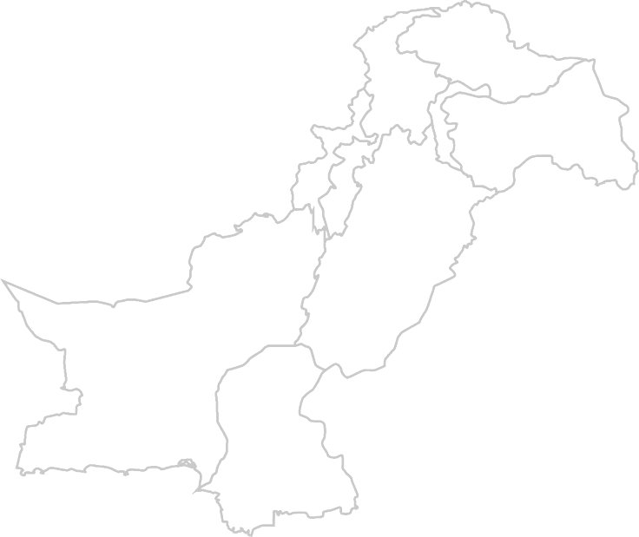

***Author:*** [***Syed Ali Sajj***](https://tribune.com.pk/author/6054/syed-ali-sajjad)***ad***

***Publication: The Express Tribune***

***Date: August 14, 2023***

***Link:***

*https://tribune.com.pk/story/2430632/how-imf-sees-pakistans-economy-in-the-near-future-part-i*

## Abstract:

The article provides an overview of the country's economic outlook and discusses the challenges and opportunities that Pakistan faces in the coming years. The author highlights the importance of listening to economic experts and using the IMF's projections to understand the country’s economic situation. In this article, the author says that according to IMF reports Pakistan’s economy is expected to improve but also argues that it will happen only when the country follows the IMF’s projections and directions. The author notes that the IMF is expecting a steady growth in real GDP over the next three years, stabilizing around 5% by FY27. However, the author also points out that Pakistan has a history of current account problems whenever its real GDP surpasses 4%. Additionally, the author notes that the IMF anticipates Pakistan's average CPI for FY24 to reach 25.9%, considerably higher than the government's estimate of 21%. The author also discusses the challenges that Pakistan faces in the external account. The author notes that Pakistan's growth in recent years has been driven by imports and consumption, which has minimized external reserves.

Overall, the article provides an assessment of Pakistan's economic outlook. It is important to note that the projections are contingent on the implementation of necessary reforms. If Pakistan is successful in addressing these challenges, it could achieve sustainable economic growth in the coming years.

# *Introduction:*

Syed Ali Sajjad, is an expert economist who writes articles for “The Express Tribune.” He writes on Pakistan’s economy and current situations. In this article he describes the country’s current situations and also the IMF’s point of view and expectations from the economy of Pakistan. He says that the IMF's projections on three key indicators: economic growth, inflation, and the external account. The IMF envisions steady growth in real GDP over the next three years, stabilizing around 5% by FY27. Additionally, the author notes that the IMF anticipates Pakistan's average CPI for FY24 to reach 25.9%, considerably higher than the government's estimate of 21%. The author also discusses the challenges that Pakistan faces in the external account. The author notes that Pakistan's growth in recent spurts has been driven by imports and consumption, which has decreased external reserves. The author contrasts Pakistan's import-driven consumption model with the export-driven models of China and India. The author notes that the IMF projects the current account/GDP ratio to moderate to 1.7% by FY25. However, the author also notes that concerns persist regarding gross reserves, which are expected to remain below $16 billion even by FY28.

The author says that even though the IMF’s predictions seem good, it does not necessarily mean that Pakistan will be able to achieve them. Pakistan has a lot of problems and crises that are hindering its path of development and growth. Without solving them it will be very difficult for Pakistan to grow and to succeed.

# Outlines:

* ***Problems of Pakistan***
* ***Causes of problems***
* ***Solution of problems***
* ***Conclusion***

### Problems of Pakistan:

Pakistan is currently facing a lot of problems. Following are some current problems of Pakistan that have been a part of it for decades but are yet to be solved:

#### 1: High inflation:

Inflation in Pakistan is currently at a 30-year high, making it difficult for people to afford basic necessities. This is due to a number of factors, including rising energy prices, supply chain disruptions, and a weak Pakistani rupee.

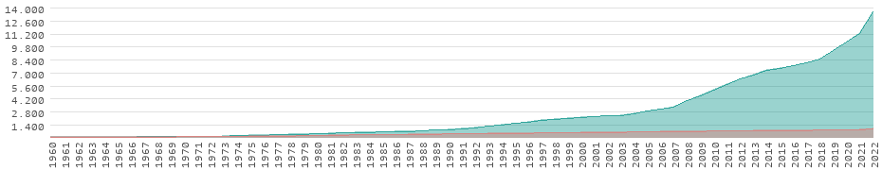

Graph: [showing increasing inflation in Pakistan along years]

#### 2: Slow economic growth:

Pakistan's economic growth has been slow in recent years, averaging around 3% per year. This is below the population growth rate, meaning that there are not enough jobs being created to

meet the needs of the growing labor force. As, shown in the graph below Pakistan economy has been very slow in development.

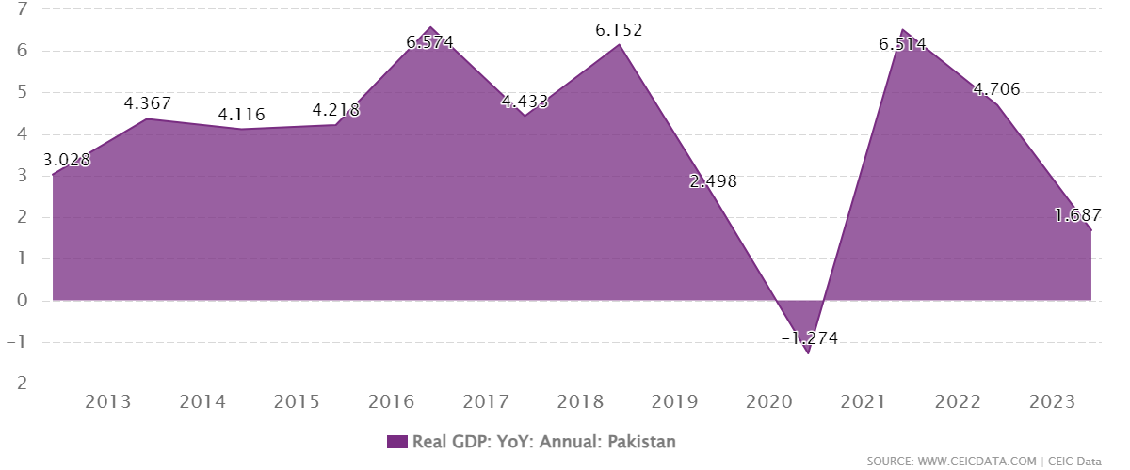

#### 3: Large external debt:

Pakistan has a large external debt, which is equivalent to around 70% of its GDP. This makes the country vulnerable to external shocks, such as rising interest rates or a decline in remittances.

4: Current account deficit:

Pakistan has a current account deficit, which means that it imports more goods and services than it exports. This is financed by foreign borrowing and investment, but it makes the country vulnerable to external shocks.

5: High unemployment:

Pakistan has a high unemployment rate, which is estimated to be around 7%. This is particularly high among young people and women.

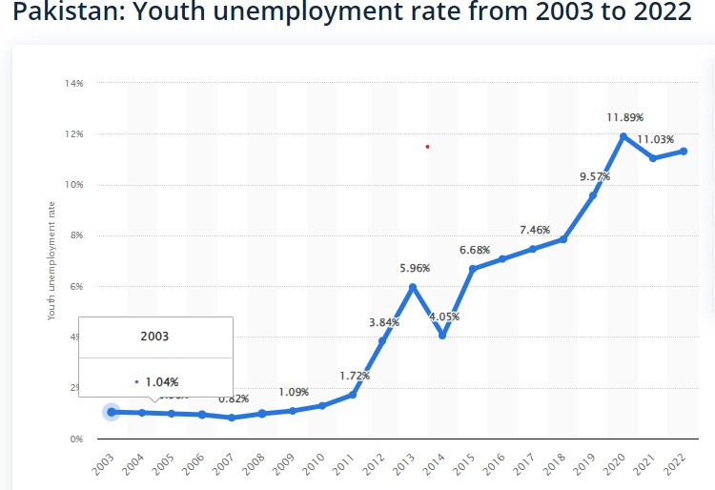

6: Poverty:

Pakistan has a high poverty rate, with around 40% of the population living below the national poverty line. This is due to a number of factors, including slow economic growth, high inflation, and inequality.

7: Inequality:

Inequality is high in Pakistan, with the richest 10% of the population controlling more than 50% of the country's wealth. This is due to a number of factors, including corruption, tax evasion, and gender discrimination.

"The great owners who must lose their land in an upheaval, the great owners with access to history, with eyes to read history and to know the great fact: when property accumulates in too few hands it is taken away. And that companion fact: when a majority of the people are hungry and cold they will take by force what they need."

(The Grapes of Wrath by John Steinbeck)

This quote highlights the fact that when there is too much inequality between the rich and the poor, it can lead to social unrest and even violence. The rich often have access to more resources and opportunities, while the poor struggle to meet their basic needs. This can lead to a sense of resentment and frustration among the poor, which can eventually boil over into violence.

#### 8: Corruption:

Corruption is a major problem in Pakistan. It is estimated that corruption costs the country around 10% of its

GDP each year. This is due to a number of factors, including weak institutions and a lack of transparency.

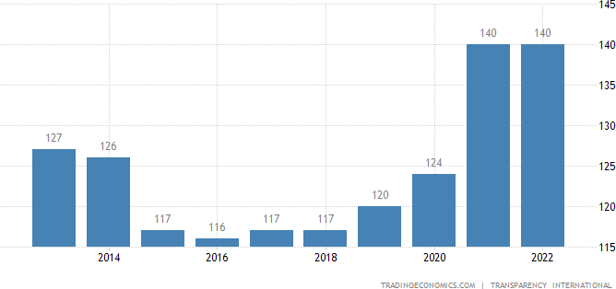

#### 9: Lack of investment:

Pakistan has a low investment rate, which is one of the main reasons for its slow economic growth. This is due to a number of factors, including political instability and a lack of infrastructure.

#### 10: Climate change:

Pakistan is one of the countries that is most vulnerable to climate change. Climate change is already having a negative impact on the country's economy, through droughts, floods, and other extreme weather events.

### Causes of Problems:

A lot of things have held back Pakistan till now, and have been affecting its growth. Some of them are briefly described here:

* High energy prices:

Pakistan imports a significant amount of its energy, and the recent surge in global energy prices has had a negative impact on its economy. Even though Pakistan has a lot of coal and gas reserves, the country still has to import the majority of the fuel. This is all the result of miss-management and corruption.

* Supply chain disruptions:

The COVID-19 pandemic and the war in Ukraine have caused significant disruptions to global supply chains, which has made it more difficult and expensive for Pakistan to import and export goods. The political and global unrest always affects the developing

countries very much so Pakistan is also facing difficult times.

* A weak Pakistani rupee:

The Pakistani rupee has depreciated significantly in recent years, which has made it more expensive for Pakistan to import goods and services.

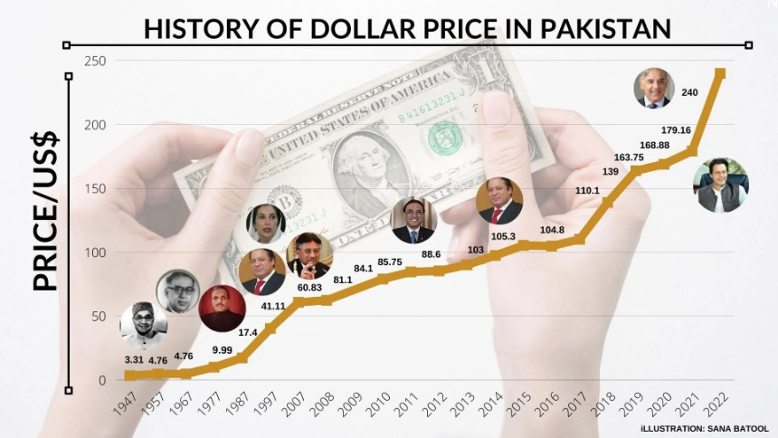

* Political instability:

Pakistan has a history of political instability, which has made it difficult for the government to implement long-term economic reforms. This is the major cause of weak Pakistani economy. Investors do not invest in Pakistan because they think their money is unsafe. Moreover, this instability has led Pakistan to the today’s time where it is on the brink of DEFAULT.

* A large population:

Pakistan has a large and growing population, which puts a strain on its resources and makes it difficult to create jobs for everyone. large population means a large amount of resources but for a weak economy like Pakistan to support a big population of 230 million people is not easy. This population increase is the major reason of Pakistan’s current situation.

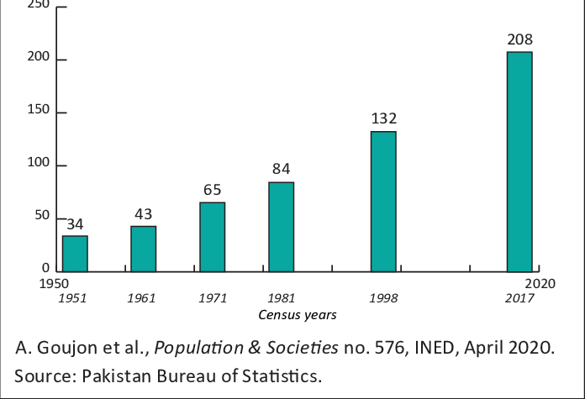

## Solution of problems:

* Diversifying the energy mix:

Pakistan needs to diversify its energy mix and reduce its reliance on imported energy. This can be done by investing in renewable energy sources such as solar and wind power.

* Improving the efficiency of the energy sector:

Pakistan also needs to improve the efficiency of its energy sector. This can be done by reducing energy waste and improving energy transmission and distribution networks.

* Promoting exports:

Pakistan needs to promote exports in order to earn more foreign currency and reduce its trade deficit. This can be done by making it easier for businesses to export and by providing financial incentives to exporters.

* Attracting foreign investment:

Pakistan needs to attract more foreign investment in order to boost its economy. This can be done by creating a business-friendly environment and by offering tax breaks and other incentives to foreign investors.

* Reducing corruption:

Corruption is a major problem in Pakistan, and it is important to reduce it in order to improve the economy. This can be done by strengthening institutions and by increasing transparency and accountability.

* Improving education and healthcare:

Pakistan needs to improve education and healthcare in order to create a more skilled and productive workforce. This can be done by increasing investment in education and healthcare and by making these services more accessible to the poor.

* Control population growth:

The government can control population growth by promoting family planning and investing in education and healthcare.

## Conclusion:

In this article, the author tries to tell that in spite of the weak economy and poor conditions Pakistan is still expected to improve itself. Pakistan can perform a lot much more than the expectations if the necessary steps are taken. The Pakistani government has to devise some method to improve the country's economic conditions. Everyone in the country should work for its prosperity. If the government along with every citizen does the job assigned to him / her properly then this Pakistan can also become a developed country. We need to realize where we are standing as other countries and IMF etc. will ultimately stop helping us and we have to do this on our own. So, the government should make a long-term plan for the country and everyone should work hard to make this country a better place for everyone.

## REFERENCES;

* ***Graphs from Wikipedia and google***
* ***World bank governance***
* **{Image credit :** [**www.geo.news.pk}**](http://www.geo.news.pk/)
  + ***Economy (Javed Chaudhry column)***
  + ***Transparency International (TI)***
  + ***IMF (International Monetary Fund)***
  + ***References and information credit Google and The Express Tribune***
  + ***NAB (National accountability bureau) Pakistan***
  + ***The DAWN***
  + ***The Express Tribune (44bn corruption scandal) May 06, 2014***
  + ***OCED-Anti Corruption***